**No silver spoon : lots of talent**

**David Christopher Davies FGS : 1827 to 1885**

David Christopher Davies was born on the 12th September 1827. Baptised one month later at St. Oswald’s Church, Oswestry the register names David’s father as Edward Thomas, a labourer, of Pentre Clawdd. David’s mother is named as Elizabeth Davies, a servant living in Leg Street. It appears that the parents were not married and their son was illegitimate. By age eleven he was an orphan.

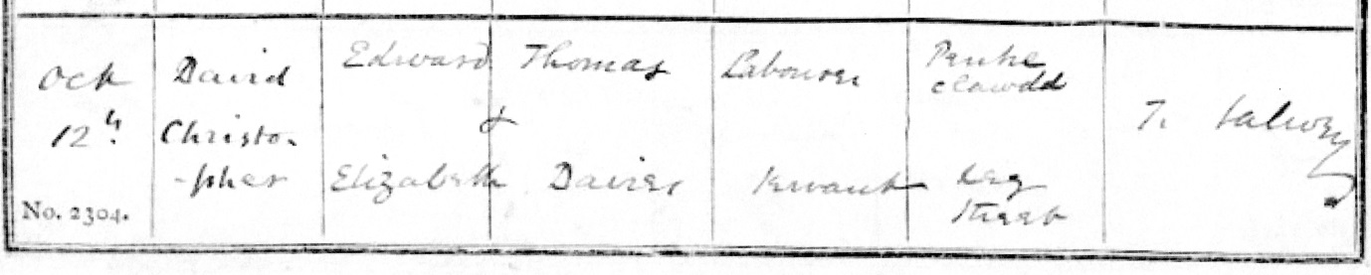

*Copy of 1827 entry in Baptismal Register of St. Oswald’s Church, Oswestry*

At the time of his death in 1885 David was tenant of a smallholding, Ebnal Lodge. His estate was valued at £1,166. The contrast between the circumstances of his birth and his financial position at the end of his life is large. One estimate of the modern value of his estate gives £1,105,480. Another gives £955,944. Whichever estimate is chosen it is clear that David made material progress. How was this change achieved?

**Youth and early adult life**

Little is known of David Christopher Davies’ early years but about age eleven Davies was apprenticed to John Minshall, an ironmonger in Oswestry. Davies learned and mastered the trade skills which underpinned the business. He also learned the business skills necessary for commercial success. Both bodies of knowledge were acquired without formal teaching. He became literate and numerate and it is reported he would rise at four in the morning to apply himself to his studies. These and his later activities show an avid mind enthusiastic for learning.

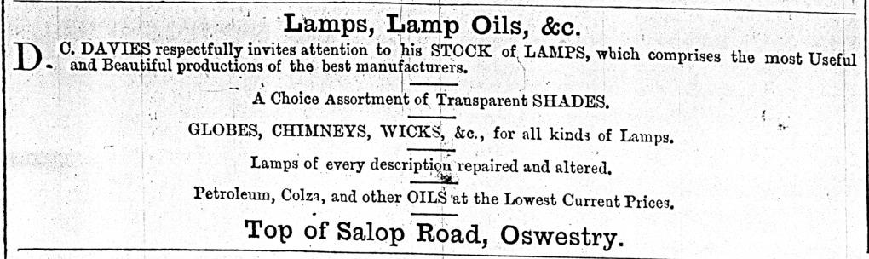The combination of experience, knowledge and skill enabled Davies to set up his own business. Trade directories and advertisements in local newspapers show Davies’ progress in business.

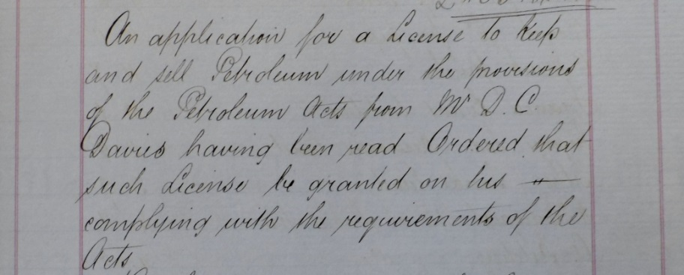 *Oswestry Advertiser and Montgomeryshire Mercury, 7 Oct 1868*

*Copy of Oswestry Town Council minute approving Davies’ application*

Davies wanted to extend the scope of his business. He needed a license to sell petroleum oils. An Oswestry and Town Council and Local Board minute of 1 Feb 1869 shows his application was granted.

**Influences and Interests**

The extended Minshall family was active in business, the Congregational Church and in the civic life of Oswestry. Their enthusiasms were part of Davies’ youth and early adult life but he developed his own interests in the church, business, Natural History and Geology. The depth and breadth of his activities led to an informed man who wrote and spoke well about his many interests.

**Friendship with William Whitwell**

A collection of letters that Davies wrote to William Whitwell is in the National Library of Wales. The letters are windows to Davies’ interests and activities, his anxieties and doubts. The first of the surviving letters is dated 15 May 1865. The last is dated 4 July 1874.

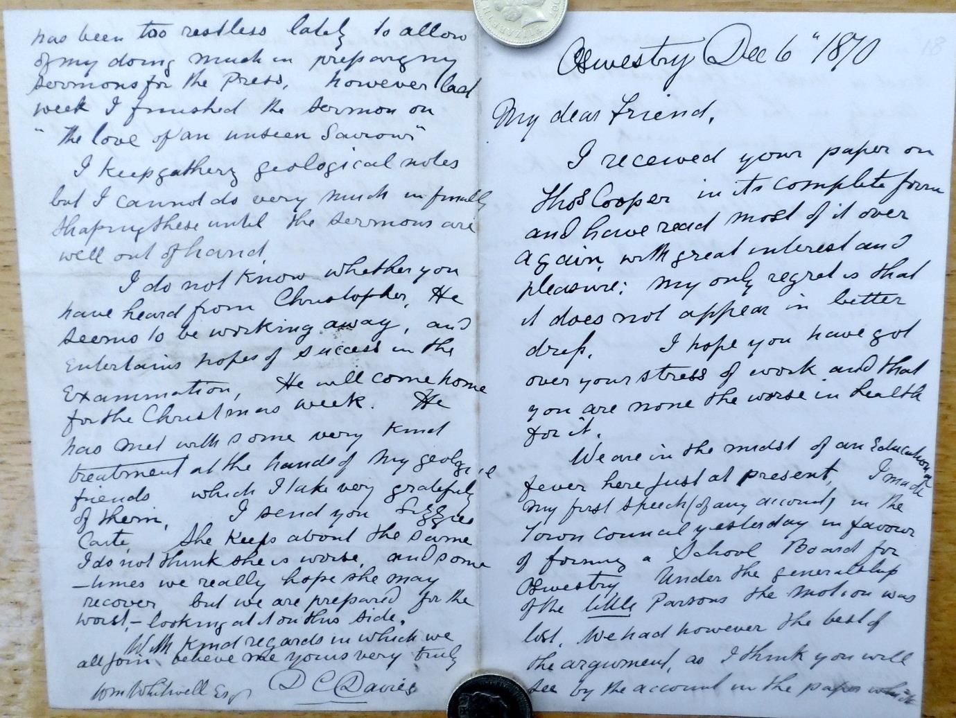A letter dated 6 Dec 1870 shows some of Davies’ activities and enthusiasms.

This first extract shows Davies has become a member of Oswestry Town Council and Local Board. The Education fever arises from debate about new powers allowing councils to become responsible for providing education in schools. Davies was in favour of council provision. He and those who shared his view were in a minority. Nevertheless, Davies thinks “We had the best of the argument.” He is disappointed but not resentful.

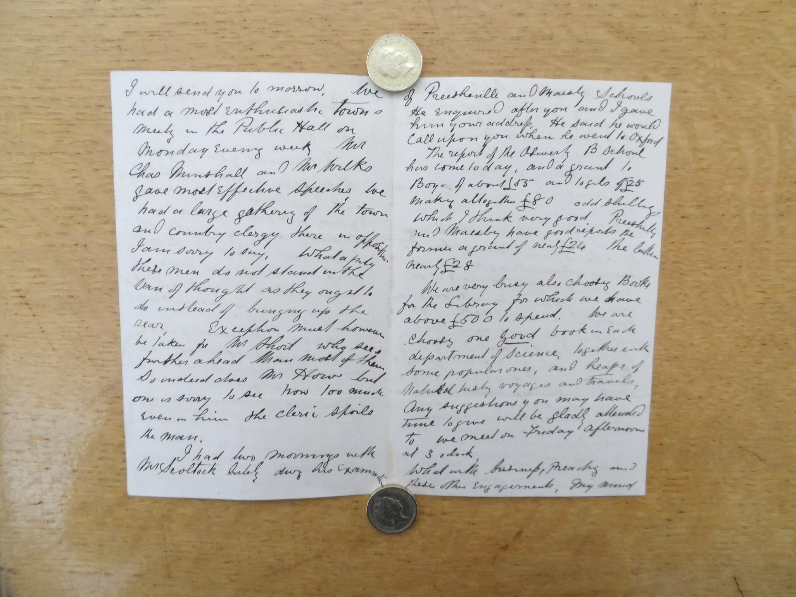

This second extract from the same letter tells of efforts to provide suitable books for a library. Libraries then resulted from local enterprise. Interested groups made their own decisions about purchases, borrowing, loans, fines and charges. Generally it was thought that membership should be paid for. In a discussion about charges Davies agreed with a proposed charge of two pence a week.

Davies had developed into an active citizen, public spirited, interested in civic life, a businessman, author and active churchman.

**Man of Faith**

Minshall family members were active in the Congregational Churches in Oswestry and at Preeshenlle. Davies had been apprenticed to John Minshall and it is likely that the growing and maturing Davies was introduced to church life by them.

David’s growing spiritual experience led to his acceptance in the lay ministry of the church. His sermons were received with warm respect. Some were published in 1871 in his book “*The Christ for All Ages.”*

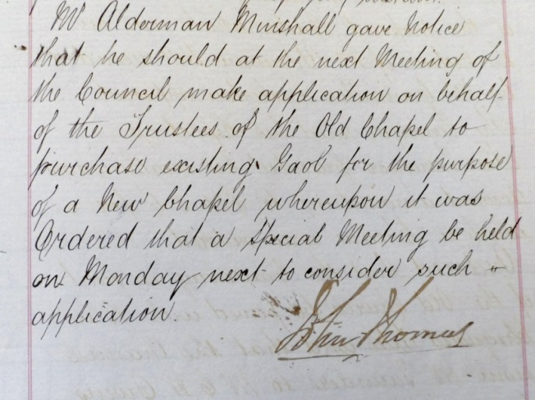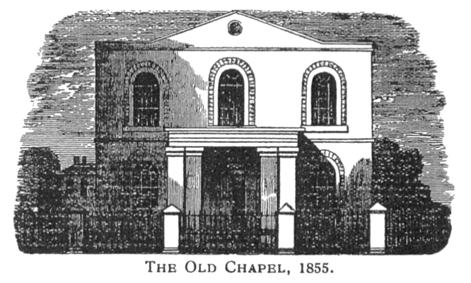During the nineteenth century Congregational Church membership grew substantially in Oswestry and the surrounding area. An existing chapel in Arthur Street, which came to be known as the Old Chapel, had been enlarged in 1830but by 1878was considered too small for its congregation and associated Sunday Schools.

It was decided to build a new church and to make substantial alterations to the existing building. The projects took place at the same time and the church made temporary use of the Assembly Rooms. Many members of the church were involved in these developments. Davies was a member of the Building Committee.

A new church meant land had to be bought. A minute of the meeting of the Town Council on July 5th 1869 records the interest of the Old Chapel Trustees in purchasing the existing Gaol and its site. Conveyances were authorised for approval on 3rd April 1871.

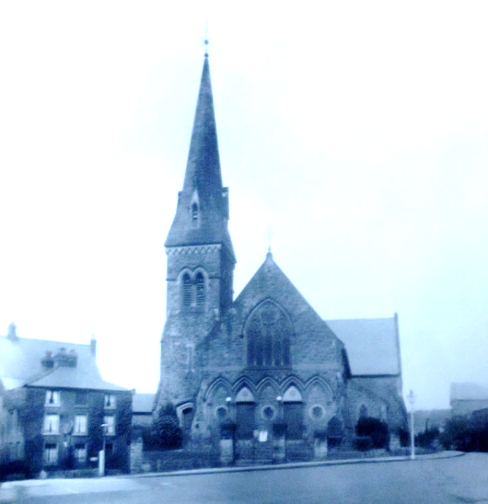The new church was named Christ Church. At its official opening on 18 Oct 1872 there was a large congregation on the site of the Old Gaol between Arthur St. and Chapel St. facing Pitcher Bank. Representatives of other denominations were present including Baptists and Methodists. Of the several speeches made at the official opening David Christopher Daviesproposed,

*“The health of the architect and the contractors, the result of whose labours had been the erection of a building which was a credit to the town, and a beautiful object in the landscape.”*

*Christ Church, Arthur Street, Oswestry*

**Husband and Father**

David married Ellen Davies of Ellesmere in 1849. They had three daughters and two sons. George Christopher was born in 1850 and Sarah Elizabeth, known as Lizzie, was next in 1854. Mary Jane arrived in 1855 followed by Edward Henry in 1858. Lastly there was Lucy Ellen in 1861.

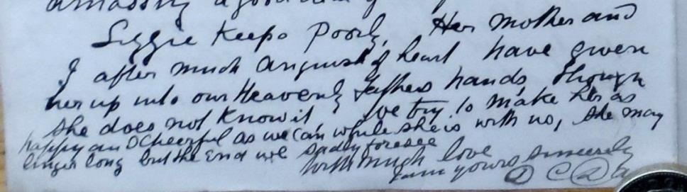David’s letters to William Whitwell say little of his wife although on one occasion he writes saying that Mrs. Davies *“knows about these things as women do.”* She does have a couple of short breaks without David. One is an extended visit to Shrewsbury. The other is a visit at the suggestion of their doctor. Both parents accompanied their ailing daughter Lizzie (Sarah Elizabeth) *“to Llandudno to benefit from the sea air.”* David used some of this time to collect fossils and of necessity returned home before his wife and daughter.

Concluding his letter of 19 Oct 1870 David wrote….

Lizzie died three months later, early in January 1871.

George Christopher had his father’s talent for writing. He worked in public administration ending up in Norfolk. Edward Henry followed his father in his enthusiasm for geology and mining. He was admitted as a Fellow of the Geological Society and qualified as a Mining Engineer. He also contributed some diagrams for his father’s treatises.

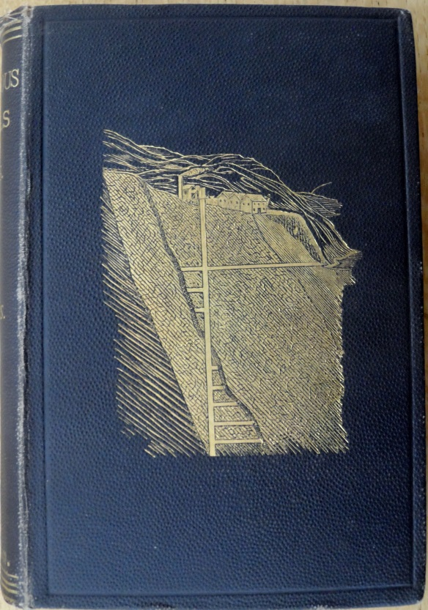Both Mary and Lucy had work to do on the smallholding at Ebnal Lodge where six cows were kept. Among other dairy tasks they made butter. Mary Jane married and had three children. She lived until September 1932. Five children were born to Lucy Ellen and her husband. She died in June 1935.

**The Author**

Davies wrote extensively. For him writing was at first an enjoyable activity which added to his income. However when times changed he was obliged to write for money. In 1870 he was working on two major projects. *“The Christ for All Ages*” appeared in 1871.

Davies’ first geological book, a *“Treatise on Slate and Slate Quarrying”* was published in 1878. He intended this and other books to be of practical and commercial value.

In 1881 Davies published his *“Treatise on Metalliferous* *Mines and Mining”*. It ran to six editions. The last appeared in 1901, sixteen years after his death, having been edited by his son Edward Henry Davies. Almost one hundred pages are about gold and silver. Prospective investors are urged to be cautious and guard against speculation.

*Front cover of “A Treatise on Metalliferous Mines and Mining”.*

*“A Treatise on Earthy and Other Minerals and Mining”,* published in 1884, was the last of his three major geological books. Davies had intended to publish a fourth major geological book but it was incomplete when he died.

**Writing for journals**

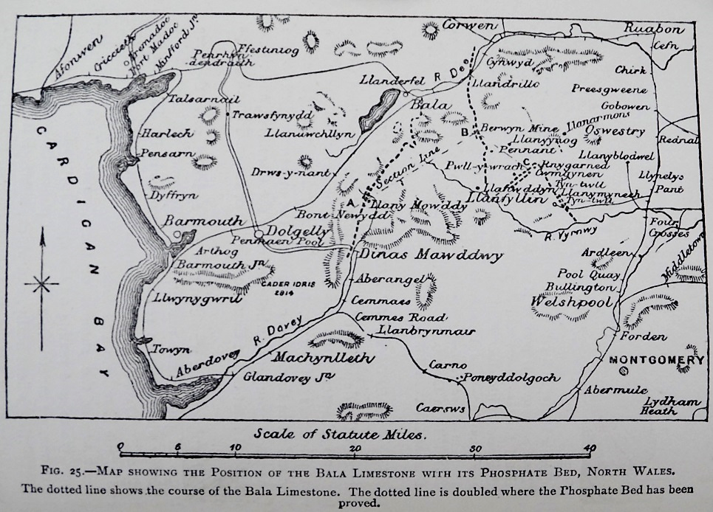Davies wrote many articles which were published in a wide range of journals. Among them were the British Architect, British Quarterly, Iron, Liverpool Geological Society, Powysland Club, Geological Association, Geological Magazine, Quarterly Journal of the Geological Society and the Colliery Guardian. Many of these journals had a national readership. Often copies were shared making the readership much larger than the print run.

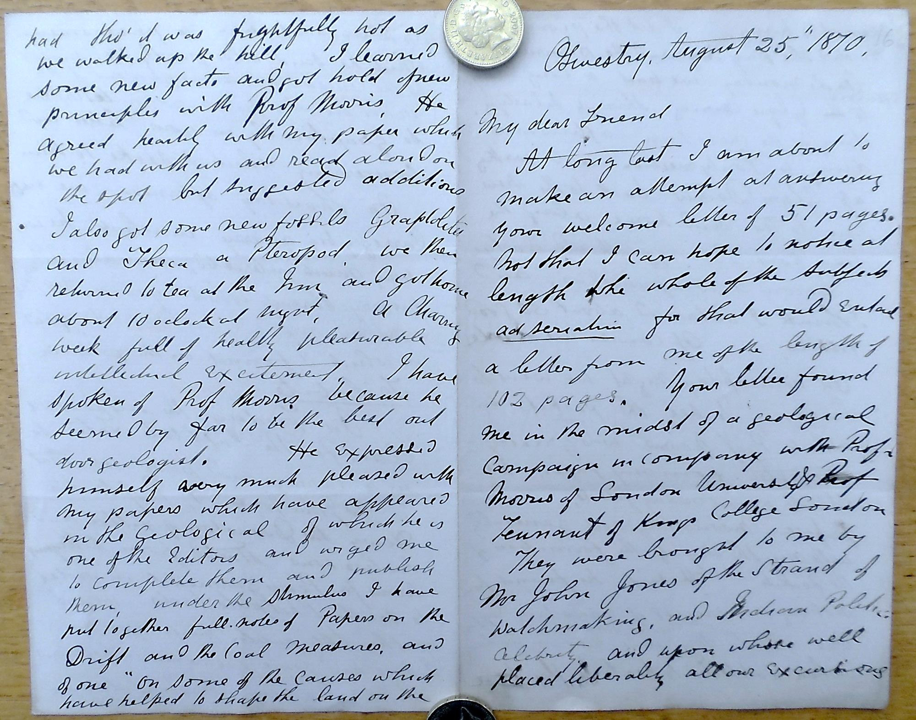An article by Davies in the Geological Magazine for June 1867 concerned phosphorite deposits in North Wales. Subsequently Davies had been involved in opening up a mine at Cwmgwynen. Information gained there led to a further article which built upon the first. This second article, The Phosphorite Deposits of North Wales, appeared in the Quarterly Journal for August 1875.

*Map from “Treatise on Earthy and Other Minerals and Mining”*

Davies’ articles were widely read. Professors Morris and Tennant visited the Oswestry area in the summer of 1870. Davies led the geological excursion, enjoying their company and being appreciated by them.

*The extract to the right is from his letter of 25 August 1870.* Davies must have felt very encouraged.

Davies was admitted as a Fellow of the Geological Society in 1872.

**Competitive Writing - Successes in Eisteddfodau**

Davies was a prolific and varied writer. He gained a prize of thirty guineas at Caernarfon in 1880 for his paper on “*Metal Deposits in Denbighshire and Flintshire”.* That success was followed by his admission to The Gorsedd. His successful paper, “*Fisheries of Wales”*, gained him twenty guineas at the Liverpool Eisteddfod in 1884.

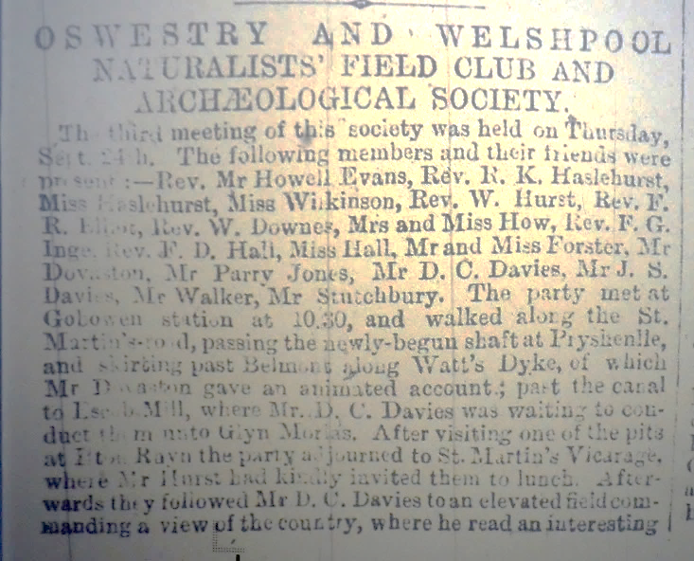**The Naturalist**

While Davies’ business and church activity commanded much of his time he still had energy to pursue other interests. A founder member of Oswestry and Welshpool Naturalists Field Club and Archaeological Society he features in a report of its third meeting on 24th Sept when the club had a full day excursion. Davies’ contribution concerned the geology of the landscape as seen from Ifton Rhyn. In his extensive correspondence with William Whitwell Davies talks of “our club” and remembers it and his friend with great affection.

*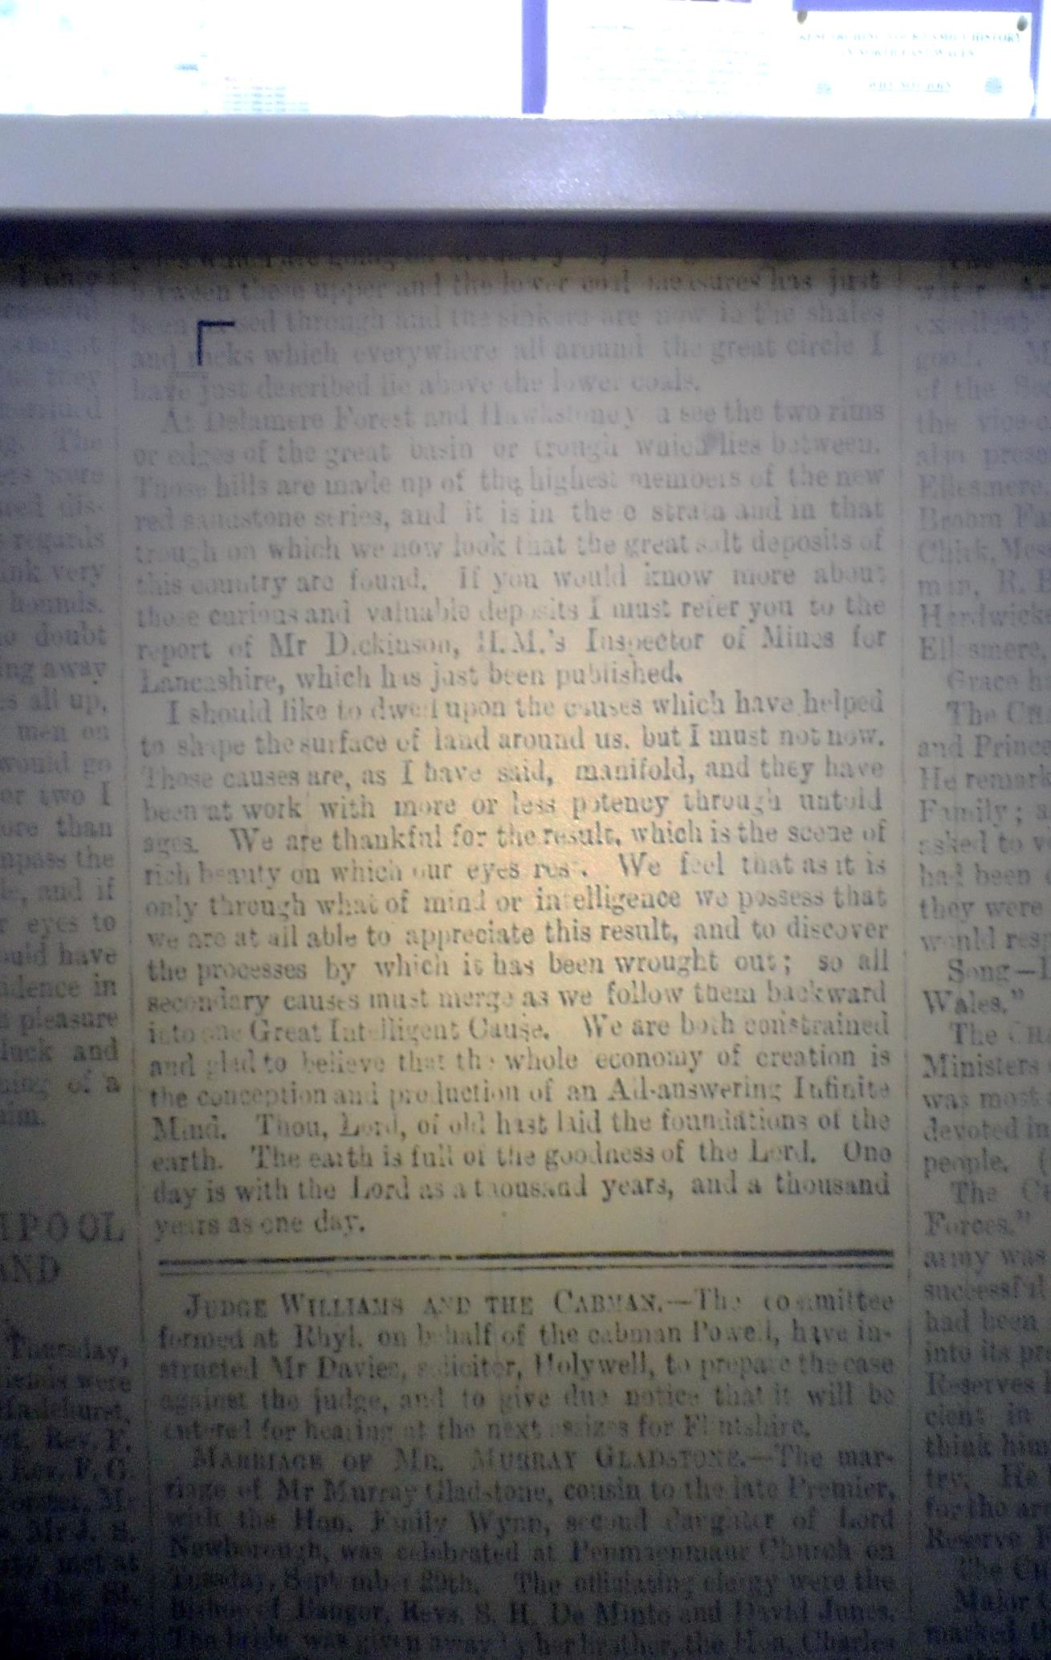Davies’ concluding remarks shown below* *blend his scriptural knowledge with his interest in natural history and geology.*

**Preeshenlle**

The first Congregational Chapel at Preeshenlle opened on Jan 1st, 1832. In effect it was a branch of the Old Chapel, Oswestry but it became a separate church at the end of 1832. In 1862 the *“members determined to erect a larger and more convenient and more beautiful”* building. The foundation stone was laid on 1 June 1868. Davies preached the last sermon in the old premises. The new chapel was much larger and included a schoolroom. Following his removal to Ebnal Lodge Davies became responsible for leading the monthly communion.

**Overseas Developer**

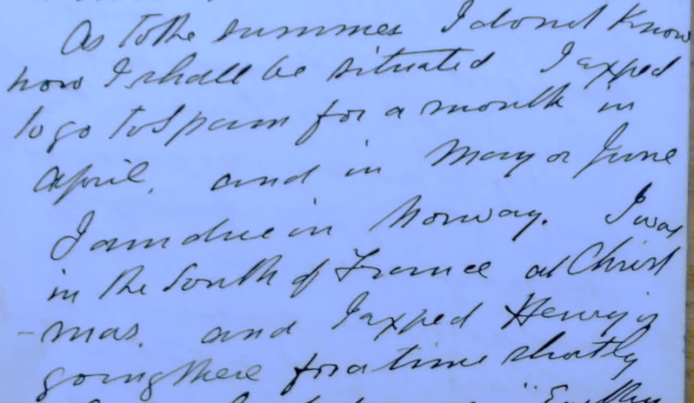Replying to William Whitwell on 15 Mar 1884 Davies wrote describing his expected journeys to Spain and Norway. He visited Norway several times and his letters mention prospects of lead and silver. Davies had also been involved in the development of a mine at Nassau in Germany.

Interest in Davies’ work, articles and books reached the United States. Two years after his death the Department of the Interior issued a bulletin quoting from Davies’ article in the Quarterly Journal of the Geological Society of London, 1875.

**The Geological Collection**

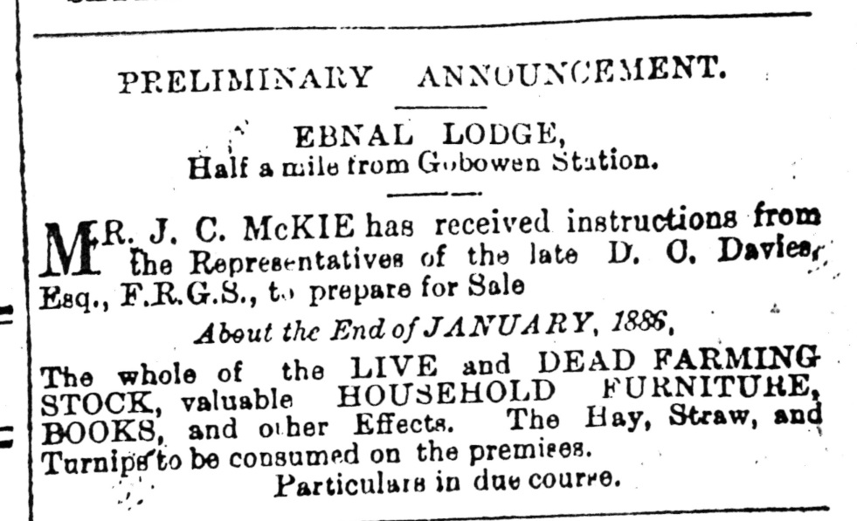Davies amassed a considerable geological collection. At Ebnal Lodge he had sufficient space to display it. While working on the development of mines at Ifton Rhyn Davies planned to have a fossil museum in one of the offices. Unfortunately this plan did not come to pass. Davies’ obituary in the Oswestry Advertiser and Montgomeryshire Mercury reported that it was only a few months before his death that Davies “*offered to present a valuable geological collection to the proposed Oswestry Museum.”* It seems Davies’ death overtook this intention.

Preliminary notice of a dispersal sale at Ebnal Lodge was given in the Oswestry Advertiser and Montgomeryshire Mercury on 30 Dec 1885. The sale included the geological collection. A letter from George Christopher Davies on 24 January 1887 to William Whitwell tells that the collection was not bought at the sale. Help is sought in finding a purchaser. The collection is then at his brother in law’s house in Maesbury. Because that family will be moving the collection needs to be sold.

William Whitwell’s reply – if any – is not known. However, correspondence in the Geological Curators Group Newsletter in 1976 and 1977 strongly suggests that the collection stayed in Oswestry, passing to the museum which was then part of the library. Items were on display in the reading room which it is reported was for a while unsupervised. A period of neglect followed until in the 1960’s advice was taken on the remaining collections. The advisor reported that most of the items were of limited interest and it was then determined that the items be disposed of.

**Endpiece**

The uncertainty of Davies’ early years is eventually followed by the uncertainties surrounding the disposal of his valued and valuable geological collection. Happily there is much certainty in between. Davies is revealed as a talented and energetic man of intellectual stature who earned and enjoyed success in much that he touched. He is to be respected as a churchman, writer, mining engineer and geologist.

That is not to say all was easy. Initial publication of his books was by prior subscription, an arrangement where people agreed to buy a copy before the book was printed. If successful the earnings from publication were his. For a while he took a rest from preaching. Following the death of his wife he wrote of his loneliness. Development at Ifton Rhyn colliery presented difficulties which caused a financial set- back for both Davies and his son Henry. However, their geology was sound. Ifton Rhyn eventually became the most productive mine in Shropshire, closing in 1968.

There is no picture of Davies in this article. Possible photographs exist locally but no certainty attaches to them. Certainty attaches to the mental picture of a talented man, skilled and capable, who worked for the benefit of others as well as himself. He was held in esteem and is still to be esteemed.

**Sources**

1. National Library of Wales: *Minor Deposit 1350A*

2. Oswestry Town Council and Local Board minutes: *1870, 1871, 1872*

3. Oswestry Advertiser and Montgomeryshire Mercury: *1868 to 1886*

4. Shropshire Archives: *SRO 5110 Records of Christ Church Oswestry*

5. Geological Curators Group: *Newsletter 1976 and 1977*

6. Shropshire Caving and Mining Club: *Autumn Issue No.96 p6*

**Thanks to**

Sandy Best, Sara Cox and Pam Willing, members of Oswestry Family and Local History Group for their interest and help

Mrs. Mary Hilary, Secretary at Christ Church, for identifying records and giving general support.

David Preston, Clerk to Oswestry Town Council, for permission to copy and use Council minutes.

Staff at Shropshire Archives for their help with searches, permissions to copy and use some records.

**©Charles Stiles Oswestry Shropshire 29 Feb 2016**