**How an Oswestry teacher spent WW1 interned in Germany**

Geoffrey Buyers, son of James and Jessie Buyers, was born in Birkenhead in 1885. His father was a high school grade schoolmaster, and Geoffrey decided to follow in his father’s footsteps.

In 1904 he graduated from Liverpool University and two years later he added an Education Diploma to his qualifications. After a year spent in Germany he then obtained his M.A. degree for a thesis on “The Influence of Schiller on English Literature”; a thesis which was subsequently published by the university

From 1908 to 1912, he was at Lady Manners School, Bakewell under the headship of W.H.C. Jemmett and when in January 1914, the High School for Boys was opened in Oswestry and Mr. Jemmett was appointed its first headmaster, Geoffrey Buyers was invited to join the staff as senior master.

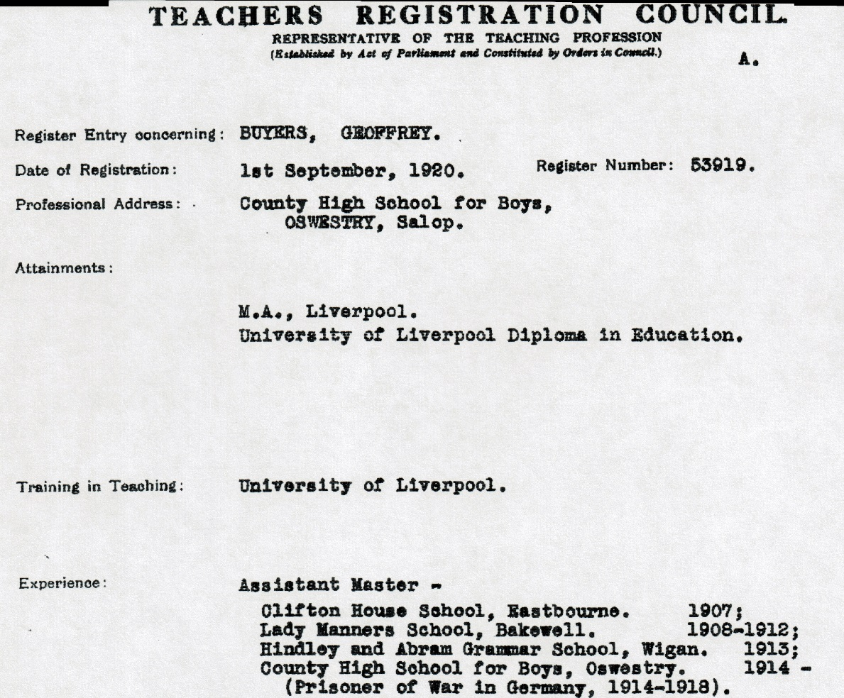

At the end of July 1914, he went to Germany for a holiday course, where he was overtaken by the events of that fateful summer.

On September 9th about forty British “suspects” were transferred from Berlin to the racecourse at Ruhleben. They became the first inmates at Germany’s new internment camp for British civilians. Ruhleben was to become Geoffrey’s home for the next four years.

Initially the prisoners were under the control of the German military and living conditions were harsh. Writing in 1916, the United States Ambassador at Berlin described conditions in the camp as follows:

“*The barracks at Ruhleben are overcrowded. The Imperial authorities, after nearly two years of war, have certainly had ample time to provide accommodation for the prisoners. It is intolerable that people of education should be herded six together in a horse’s stall, and in some of the lofts the bunks touch one another. The light for reading is bad and reading is a necessity if these poor prisoners are to be detained during another winter…..the prisoners are obliged to answer roll-calls outside, often in the rain, and have no means of drying their soaked garments……many things such as soap, usually issued to prisoners, even in jail, I am informed, have never been given to the prisoners at Ruhleben.”*

This image appeared in The Post, Sunday Special dated 8th August 1915.

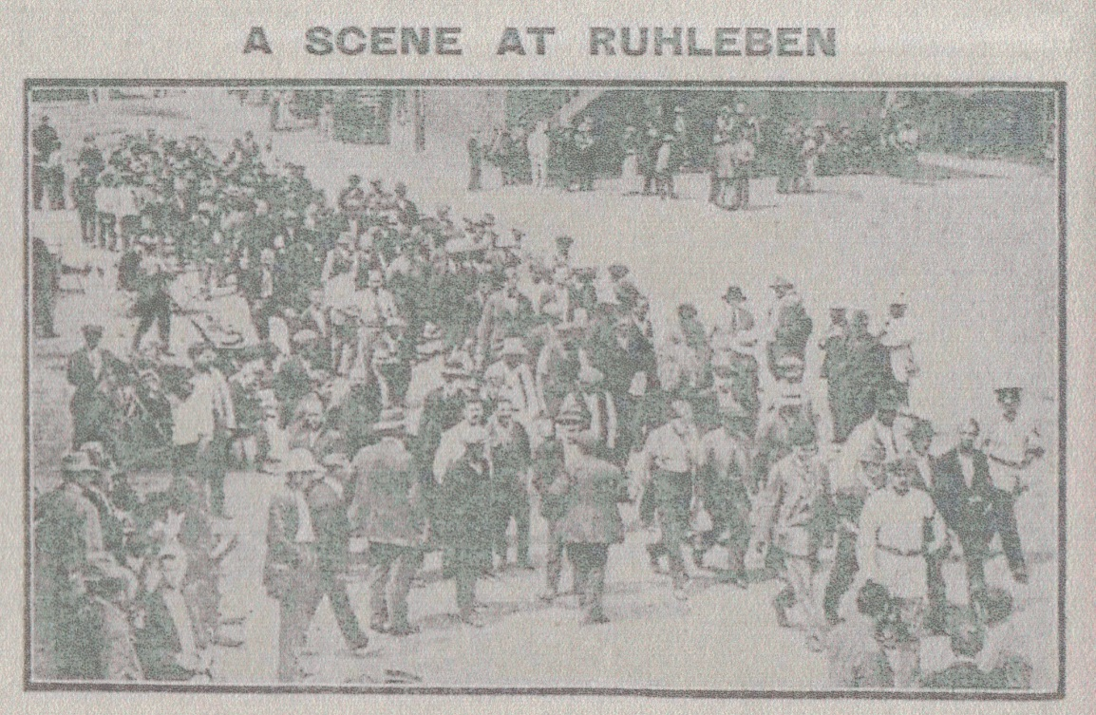

Underneath the caption reads “*The prisoners are just being marshalled prior to receiving their food.”*

One internee, repatriated to Britain in 1915, described the diet as follows:

“*Breakfast and supper every day of the week consisted of black bread and half a pint of coffee. The bread ration served out in the morning had to serve for supper as well as breakfast. Until one got used to it, the bread was almost uneatable. It was made of burnt corn, potatoes, sawdust and sand and was a good deal worse than the German “war bread” which was not allowed to the prisoners.*

*Dinner varied from day to day. Sometimes it was cabbage soup with scarcely any meat in it, potato soup another day with no meat in it, occasionally boiled rice and prunes, which the prisoners considered a great treat, and on Sundays a sort of pea soup”.*

As the war progressed the food situation was to deteriorate and in October 1917, under the heading “*No Food for British Prisoners from Germans for Three Months*”, the Exeter & Plymouth Gazette carried the following report:

*“Exchanged British prisoners who arrived at Scheveningen today from Ruhleben declare that during the last three months of their confinement in the Ruhleben internment camp no food was supplied to them by the Germans and they had to subsist entirely on food sent from England. As this consisted chiefly of tinned goods, a considerable number of the prisoners suffered from stomach disorders."*

The internees, however, worked hard to make the best of their situation. A camp education department was established; the grandstand tiers became an area for schools and lectures, and smaller rooms were appropriated for study and musical practice. A stage was erected, and a complete theatre installed with scenery, dressing rooms and orchestra etc. Performances varied from Shakespeare to musical shows.

In November 1915 the following article appeared in the Newcastle Journal:

*“A further appeal is made by the Board of Education for books of an educational character for British civilian prisoners of war, of whom there are some 4,000, now interned at Ruhleben in Germany. Under the auspices of a camp education department, a school and science and art union have been organized among the prisoners and in them are enrolled 1,500 students with 150 lecturers and teachers.”*

Geoffrey Buyers, well-read in English and German literature would have had a great deal to contribute to camp life and his name is recorded in the Ruhleben Camp Magazine (March 1916, p.36), as having given a literary lecture on Wordsworth. Also during his time in captivity he received letters from and wrote letters to pupils at Oswestry High School for Girls. One of his letters was published in the December 1917 edition of that school’s magazine; The Rilstonian.

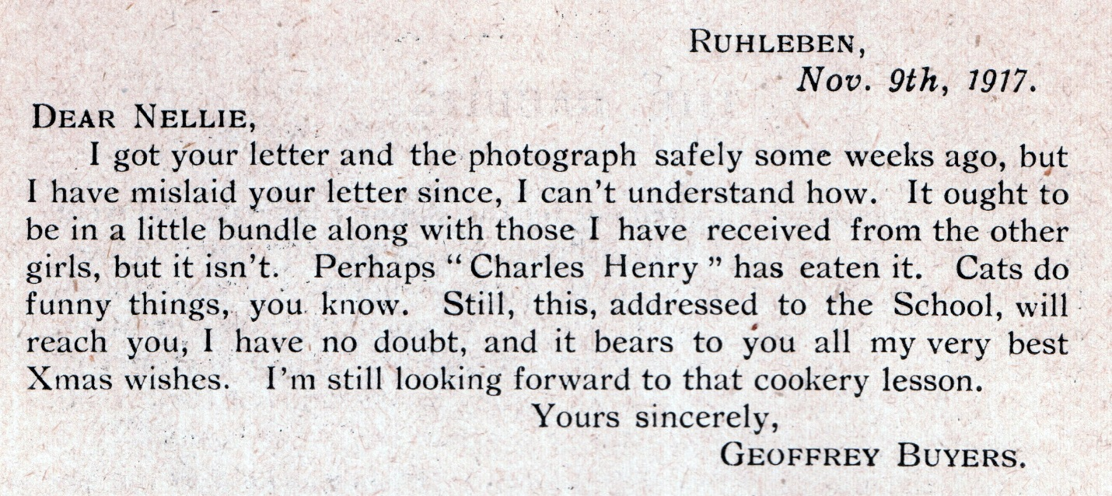

Perhaps the last word on life in Ruhleben should go to one of Geoffrey’s fellow internees. Recounting his experiences in the Coventry Evening Telegraph dated Monday 30th December 1918, Edgar Bainton, son of Rev. G. Bainton stated:

*“Arrangements were made with the English Universities and teaching bodies by which students in Ruhleben could sit for examinations, working their papers in the camp and having them sent to London for correction, so that the years spent in Ruhleben should not be wasted and their career delayed. Many students availed themselves of this opportunity, and passed such examinations as the London Matriculation, Royal Society of Arts, and London Chamber of Commerce, and one enterprising young musician actually obtained the degree of Doctor of Music during his third year of internment. The educational work at Ruhleben was a really wonderful example of the energy, enterprise, and pluck of the British character.”*

At the end of the war Geoffrey returned home to resume his teaching career in Oswestry. He married Clara Hopewell in 1921 and in 1922 a daughter, Dorothy, was born.

He rarely spoke about his time in Ruhleben, but perhaps the privations of those years in internment had taken their toll on him. In the late 1930s he began to lose the sight in one eye and in January 1941 he suffered a seizure and lapsed into unconsciousness at his home, Flowerdale, Queens Park, Oswestry. He died the next day.

The Border Counties Advertizer records:

*In announcing the sad news to the boys, the Headmaster said that the School would mourn the loss of “a scholar, a gentleman and a friend”. More fitting words could not well have been chosen. Those who knew him had long come to recognize and value his culture, his integrity and his sincerity, his modesty and his kindliness, his loyalty and devotion to his work. By his passing the school had lost a teacher with rare gifts…”*

For anyone interested in finding out more about Ruhleben camp I can recommend the website

<http://ruhleben.tripod.com/index.html>

Other source materials used:

Newcastle Journal Tuesday 22nd June 1915

Western Daily Press Wednesday 28th July 1915

The Post Sunday Special 8th August 1915

Newcastle Journal Friday 26th November 1915

Exeter & Plymouth Gazette Saturday 6th October 1917

The Rilstonian published December 1917

Coventry Evening Telegraph Monday 30th December 1918

Teachers Registration Council Certificate 1920

Border Counties Advertizer 29th January 1941.

©Pamela Willing 2014